# Lab Exercise: Installing XAMPP and Configuring it with PhpStorm

This document is a walkthrough through the process of **installing and configuring XAMPP**. After following all steps you will have fully configured XAMPP with PhpStorm integration.

This lab is part of the ["Technology Fundamentals" course @ SoftUni](https://softuni.bg/courses/technology-fundamentals).

**XAMPP** is a software package that bundles in a single package **PHP** + **Apache** + **MySQL** + **phpMyAdmin** + some other tools for PHP Web development in Windows environment.

# Part I: Installing XAMPP and Configuring the Apache Server and MySQL Database

This first part will show you how to **install XAMPP**, **start the Apache** server, and **create your first MySQL DB**.

## Downloading XAMPP

Download XAMPP version 7.2.9 from <https://www.apachefriends.org/download.html>.

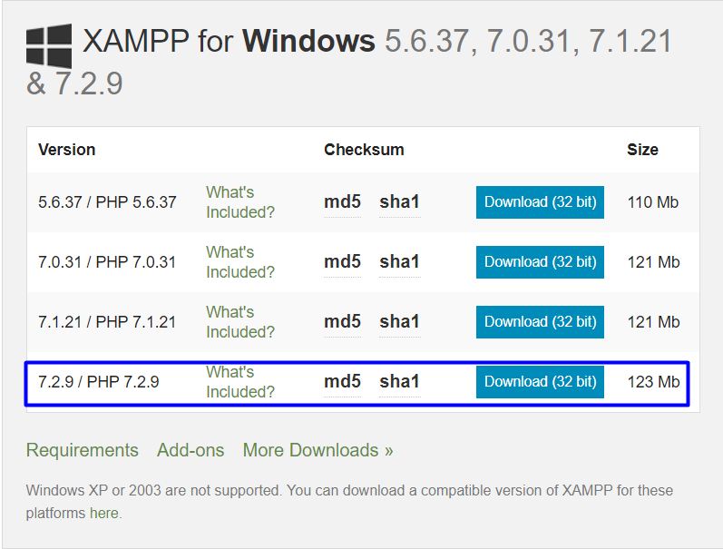

## Installing XAMPP

The pictures below will show you the steps that you need to go through, in order to successfully install XAMPP.

Install XAMPP in the **default directory** (“C:\xampp”), or you might encounter permission troubles later on.

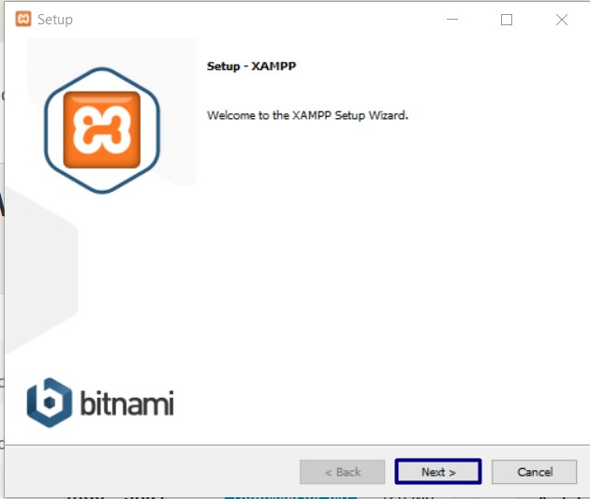

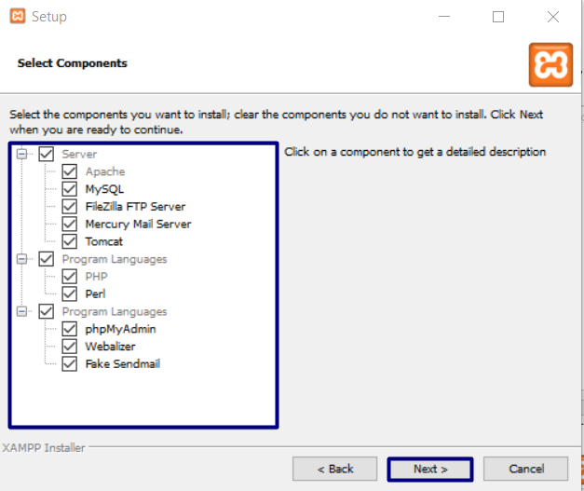

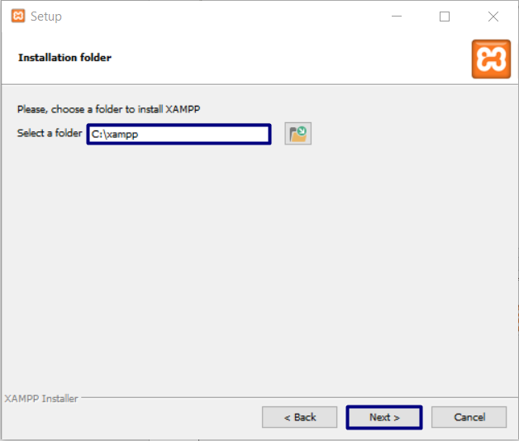

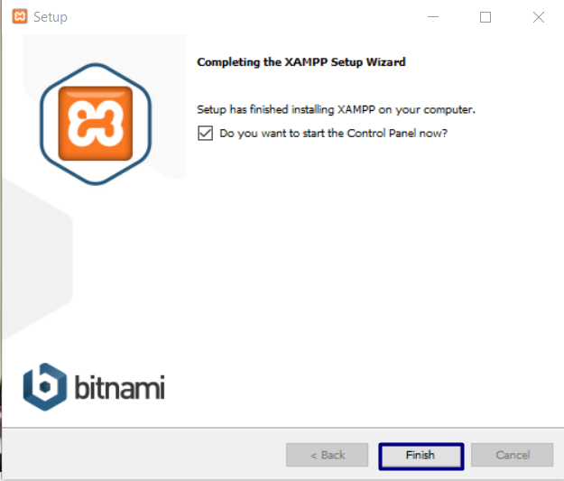

## XAMPP First Start

The first time you **start XAMPP** you will get **language selection screen** like this one:

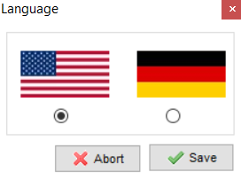

After you choose the language you prefer, you will see the **main screen of XAMPP**:

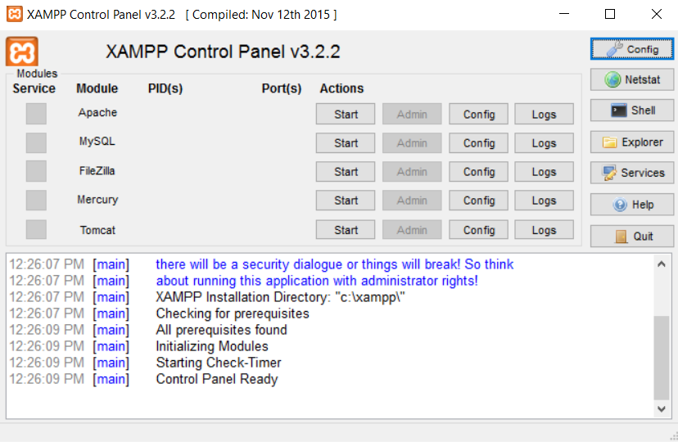

## Start Apache Server

Now we need to **start Apache server**:

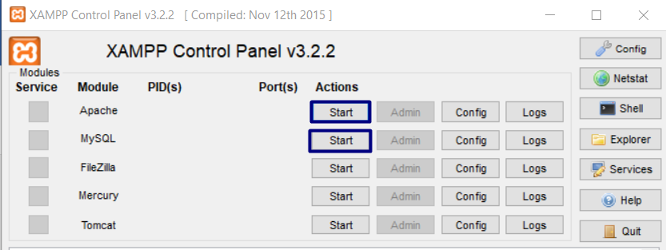

If everything is correct, the Apache label will become green, and you will see the default **ports** – **80**. If you have **Skype** or a torrent client running, the Apache server **will not start**. You need to **exit the program that holds port 80**, and the Apache server will start.

# Part II: Connect the Debugger, Apache Server and MySQL DB to PhpStorm

This part will show you how to **configure XAMPP with PhpStorm**.

## Go to the PhpStorm Home Page

If it’s the first time you start PhpStorm, it will be quite easy. You will start there. If you have started PhpStorm before, you need to either close your current project using **File** -> **Close Project** option or simply skip this step and go to **File** -> **Default** **Settings**. You should see this screen:

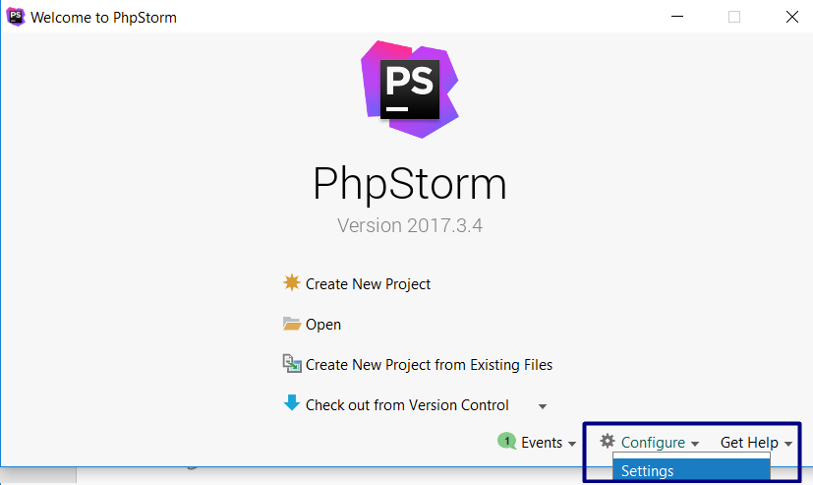

As you can see in the picture, we need to go to the settings menu.

## Install the PHP Debugger

Once we are in the settings menu we need to go to **Languages & Frameworks** tab and select **PHP**. We need to change the **PHP** **version** to **PHP** **7.2**.

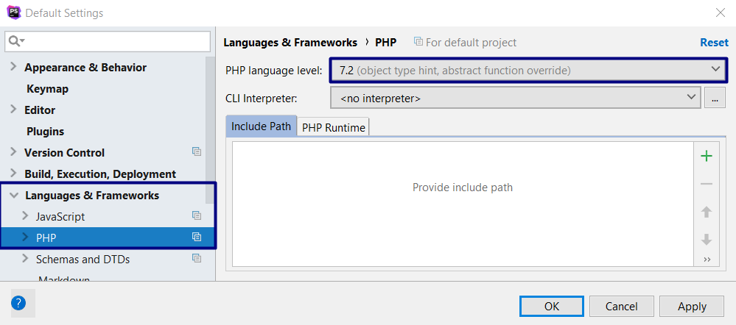

After that we need to change the **PHP Interpreter**:

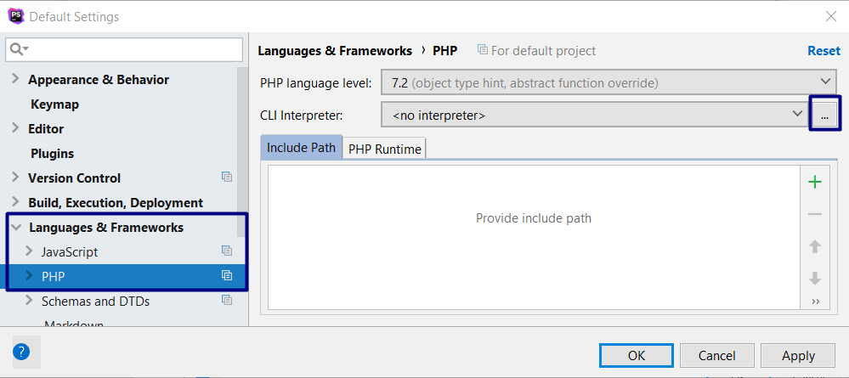

On the default interpreters page, we need to click the green plus and press **Local Path to Interpreter**.

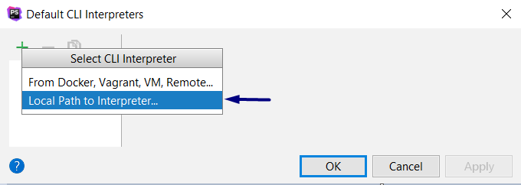

After we do that, we will see this window:

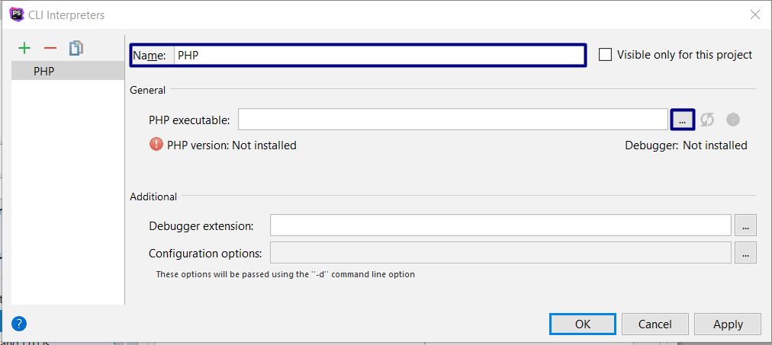

We need to choose the **PHP Executable** now. In order to do that, we need to find our XAMPP folder and choose the "**php"** directory and in it select **php.exe**

.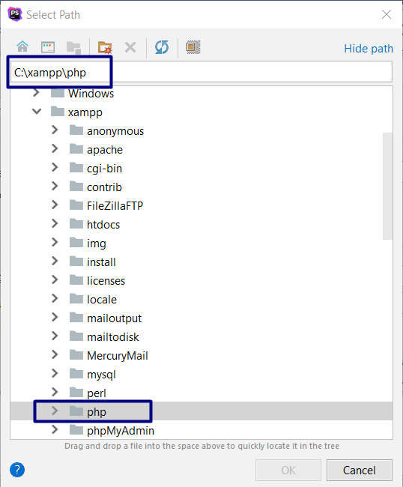

If everything is alright, you should see this:

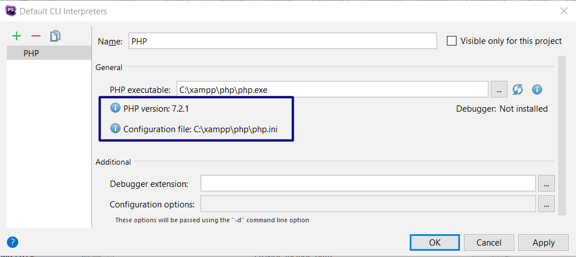

Let’s give PhpStorm a break. We need to download a debugger. We will download Xdebug from here: <https://xdebug.org/files/php_xdebug-2.6.0-7.2-vc15.dll>. Place the downloaded file to "C:\xampp\php\ext".

Now we need to **edit** the **php configuration**. Open the **php.ini** file located in "C:\xampp\php\php.ini".

Once you open the file add the following lines:

|  |
| --- |
| **[Xdebug]**  **zend_extension = "C:\xampp\php\ext\php_xdebug-2.6.0-7.2-vc15.dll"**  **xdebug.remote_enable = 1** |

**Restart XAMPP** and **run** the Apache and MySQL modules again.

If you’ve done everything correctly, you should see the following screen:

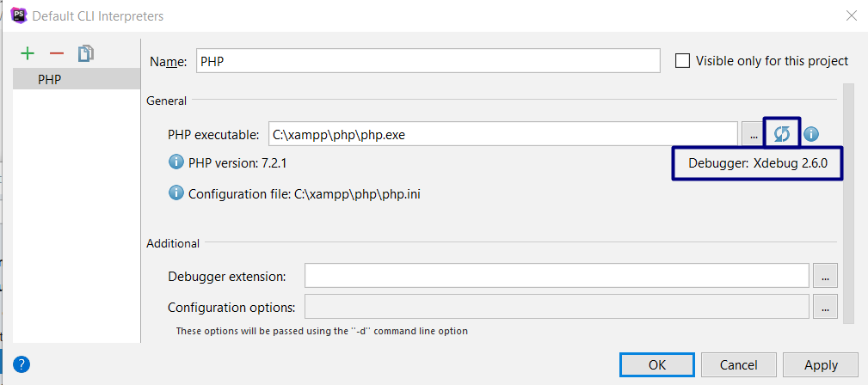

## Create PHP Debugger Configuration

Before we configure the debugger, we need to return to the home screen and create new project

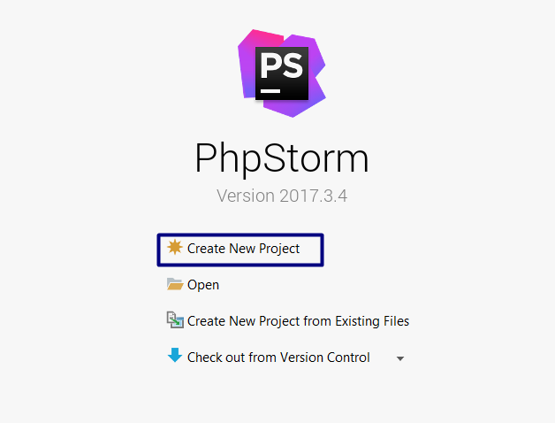

Then we need to choose **Empty PHP project** and make sure that the location of our project is in **htdocs** folder in **xampp.** We will name it “**HelloWorld**”

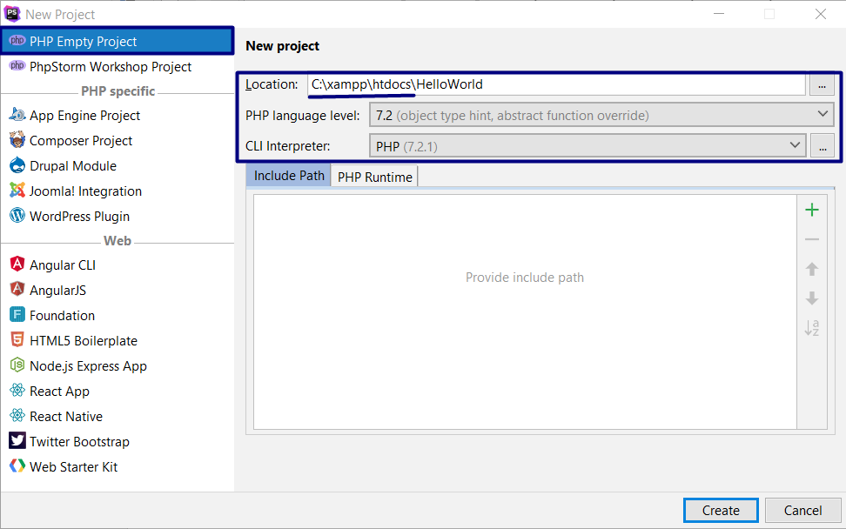

After that we need to create a new php file inside our **HelloWorld** project. Let’s name it **index**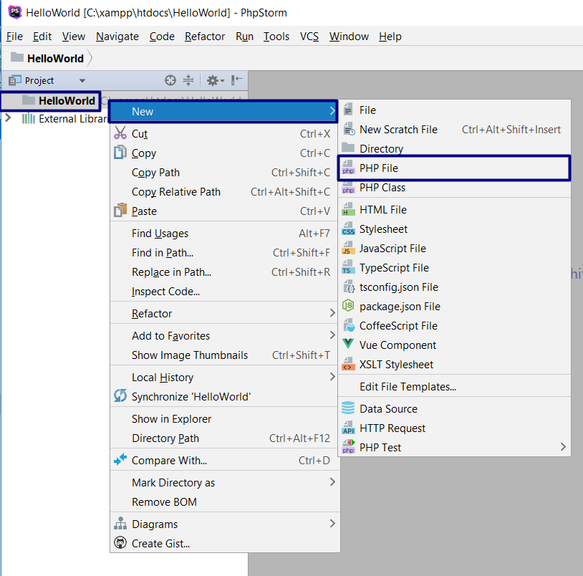

After we create the file we need to edit the configuration

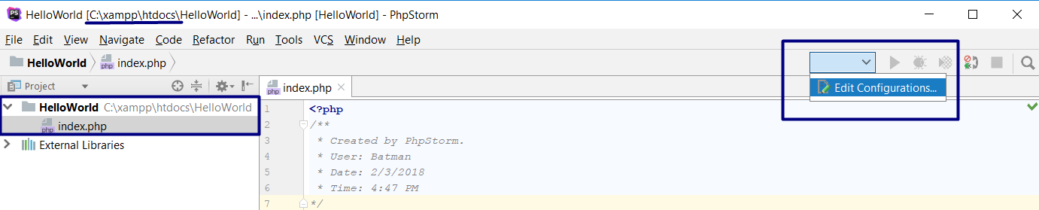

Choose a **PHP Web Page** (On old PHPStorm version it might be called **PHP Web Application**) on the drop down after you click the green plus.

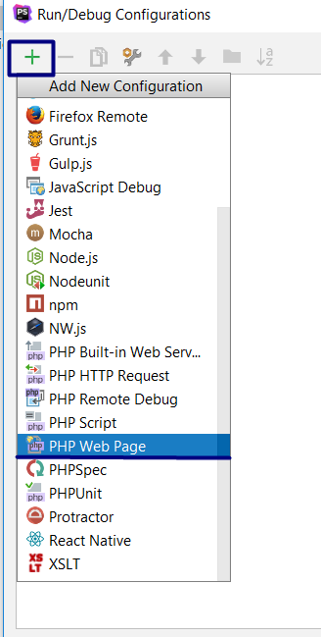

Edit the Configuration Name and **add new server**.

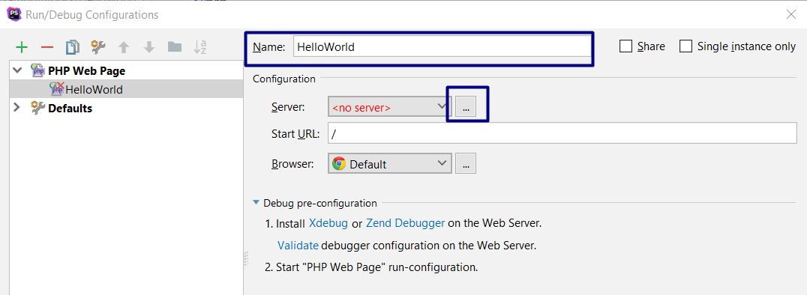

Add new server with **Host =** localhost, on **port 80** with **Xdebug** debugger.

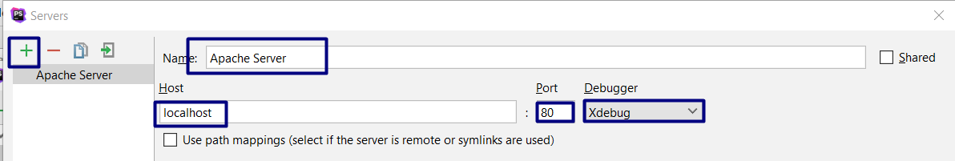

At last we need to select the newly created server, and edit the **URL**. In the URL part you need **to locate the file that you want to debug** starting from **localhost**. In the example below my file is in project HelloWorld with file name

**Index.php**.

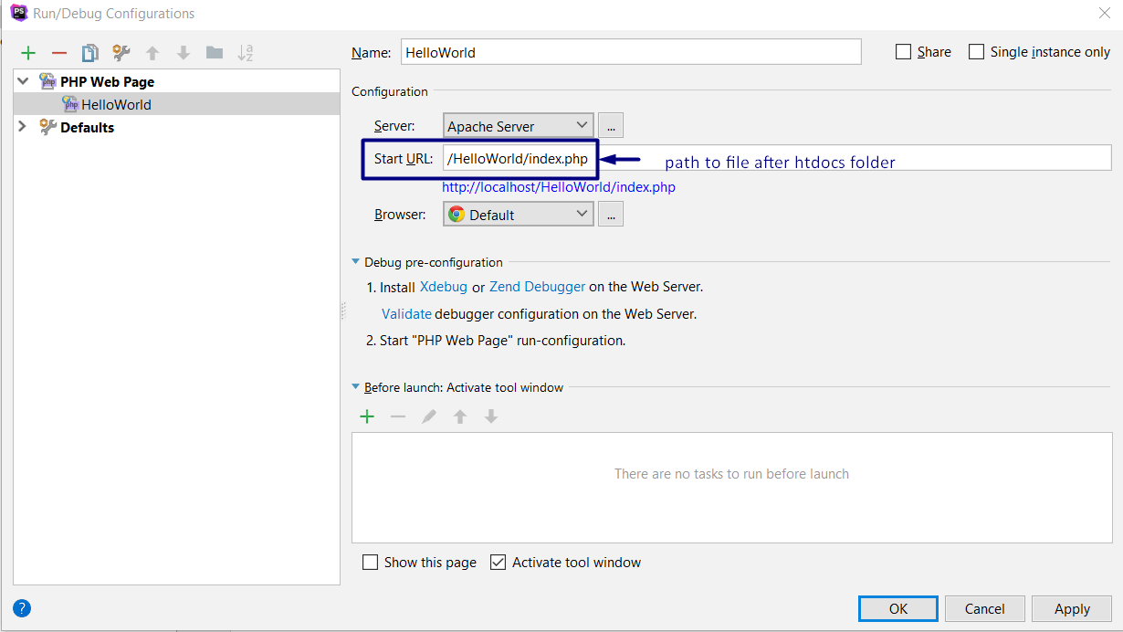

The result should be the following:



Now you are **ready** **to** **start** **using** PHP!